**Mindset and change management/leadership**

[1 comment](https://www.futurelearn.com/courses/change-management-combined/3/steps/1311440/comments#fl-comments)

We live in a world that is on the brink of chaos and certain parts of the world have already slipped into chaotic situations which have devastated the cultural, social and economic systems on which these regions depend for a stable and prosperous society to flourish. Change drivers of a political, economic, social, technological, environmental, and legal nature are enveloping organisations like snowstorms. This is a change storm that seems to have no end point. Yet we know that something is wrong, and many organisations are failing to manage change effectively. The key issue is one of leadership mindset and the choices we make regards opting for a Growth or a Fixed Mindset.

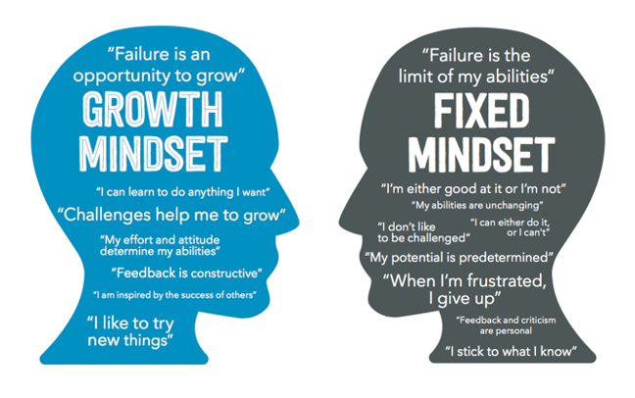

A mindset can be considered as an attitude, based on a belief system, towards some aspect of ourselves. Indeed Carol Dweck (2017), a world thought leader on the subject, defines mindset as a form of ‘self-theory’ that a person has internalised about themselves. She illustrates this idea with the contrasting belief that two people may hold regards their intelligence, e.g. one may have a mindset that claims that they are intelligent , whilst the other, in contrast may hold the theory of self that claims that they are not intelligent.

Another important aspect of mindset is that often we are unaware that we hold these. They may operate below the level of conscious thought yet still have a powerful grip on our decision making. Dweck extended the idea of mindset to include two apparently diametrically opposed concepts; Fixed and Growth Mindsets. According to Dweck, in a fixed mindset, people believe their abilities, like their intelligence or leadership potential, are fixed traits thus implicitly assuming the case of nature over nurture. In contrast for people with a growth mindset they believe that their personality and capabilities all have the potential for growth and development, subject to applied study and learning, implicitly assuming nurture over nature.

This idea has profound implications for change management and leadership. We know that change managers/leaders need to commit to what Peter Senge calls self-mastery and the cultivation of team learning and these activities are highly enabled through the acquisition of a growth mindset and also highly limited by the acquisition of a fixed mindset.

Comparison between fixed and growth mindsets

• Fixed mindset builds protective tendencies to avoid learning developmental opportunities that may highlight an ability deficiency.

• A growth mindset is associated with helping others to grow and develop.

• Fixed mindsets view learning for the sake of learning as pointless; learning must be instrumental and a means to an end.

• Growth mindsets view learning as an opportunity for personal growth and deeper understanding.

• Fixed mindset involves adhering to the belief that I am fixed, my personality and intellect and identity are fixed traits.

• Growth mindset involves being open to development, “nothing about me is fixed”.

• A fixed mindset leadership focus solely on a goal-orientated culture.

• A learning development orientated culture originates from a growth mindset with goal achievement as a product of the learning and development process.

• Fixed mindsets are set up when success is attributed to innate qualities a person has.

• Growth mindsets are set up by the belief that hard work and application to learning is valued for its own sake.

• Intellect and personality cannot be developed.

• Intellect and personality can be developed.

• I failed therefore I am not good at this…. fixed mindset attitude.

• There is no failure only feedback a growth mindset attitude.

**Key lessons**

Mindsets can thus be considered as mental frameworks that guide how people think, and act and feel in any potential achievement context. For change leadership to emerge this requires a willingness to shift from a fixed mindset to a growth mindset in relation to personal development, and specifically empathy development. To understand change leadership, we must also have an appreciation of mindset, what it is, how it forms and how it shapes our personality and guides our decisions and social interactions. Mindset therefore is the most important aspect of our lived experience in this world. Through our mindsets we filter, make sense of and act on the social world and so our mindset has a not insignificant impact upon the quality of both our lived experience and our social results. Our mindsets drive our emotional, cognitive, and behavioural states and so whether we have a happy or sad experience is driven by our choice of mindset. We know that our mindsets are social constructions that have a history. We understand that they are formed from the way we frame our social experience, the stories of our life experience we establish from this framing process, and the associated beliefs and values that are generated from this sense making process.